East2West
 | TRƯỜNG ĐẠI HỌC FPT  TRUNG TÂM ĐÀO TẠO LẬP TRÌNH VIÊN QUỐC TẾ  FPT-APTECH | 
Installation Guide
Giáo viên hướng dẫn: | Pham Cong Thanh
Lớp: | GC0761
Tên nhóm | 04
Tên thành viên trong nhóm: | Tên đầy đủ |  | Mã số Sinh viên
 | 1. | Bui Ngoc Quang Anh | GC60131
 | 2. | Nguyen Anh Tuan | GC60137
 | 3. | Hoang Dinh Manh | GC60134
 | 4.

I. System requirement
Sr. | Item | Description
1. | OS | Microsoft Windows 7
2. | Database | SQL Server 2008 (User:SA, Password:123)
3. | Web Server | Jboss 5
4. | Web Browser | Internet Explorer 7.x or higher  Mozzilla Firefox 17.x or higher
5. | Fonts | Only use font Unicode : Arial, Tahoma, Lucida Console, Times New Roman
6. | Runtime Environment | Java SE Development Kit 6 (JDK 1.6)
7. | Screen Resolution | 1024x768

B. Setup
Setup database:
Step 1: Extract file eProject_group04_GC0761.rar to eProject_group04_GC0761 folder
Ex: extract file eProject_group04_GC0761.rar to “ C:\ eProject_group04_GC0761\”
Step 2 : Attach file E2W.MDF (and E2W_log.LDF) from “ eProject_group04_GC0761\ e2wDatabase\” into SQL Server after extract e2w-sourceCode-Database.rar

- Open SQL Server,login with the username and password
- Right-click on Database --> Attach
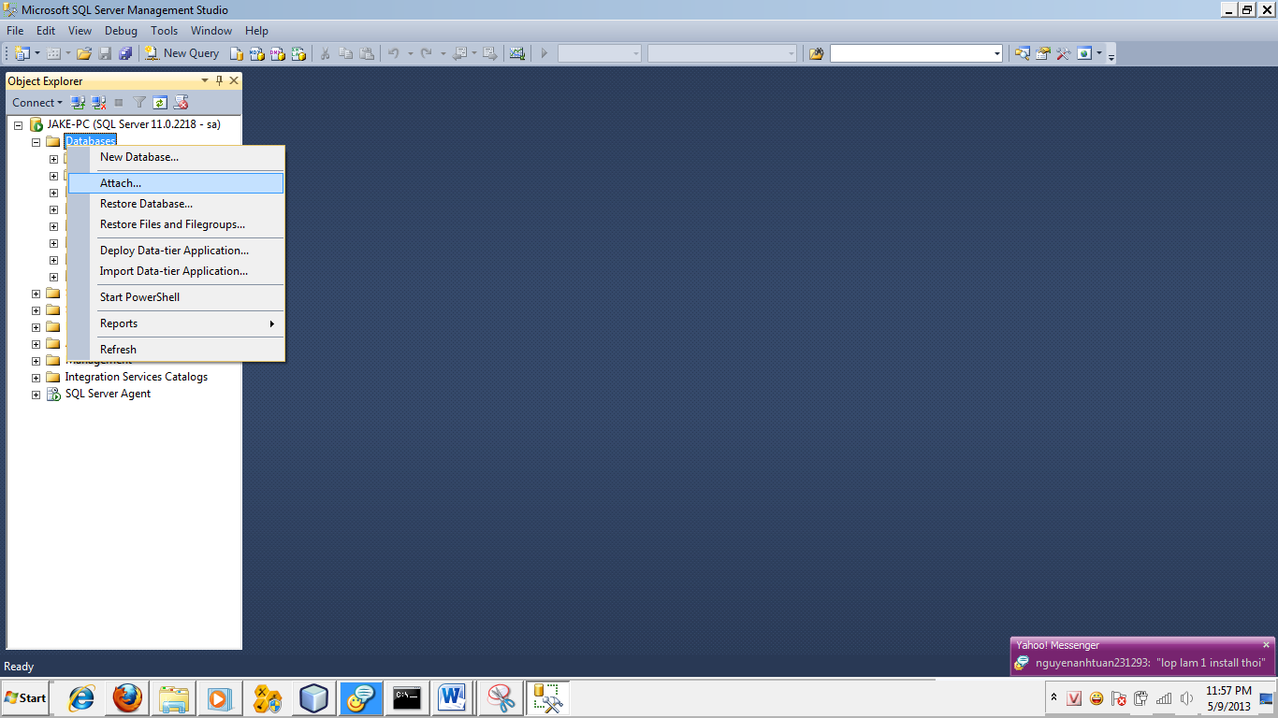
- Click Add
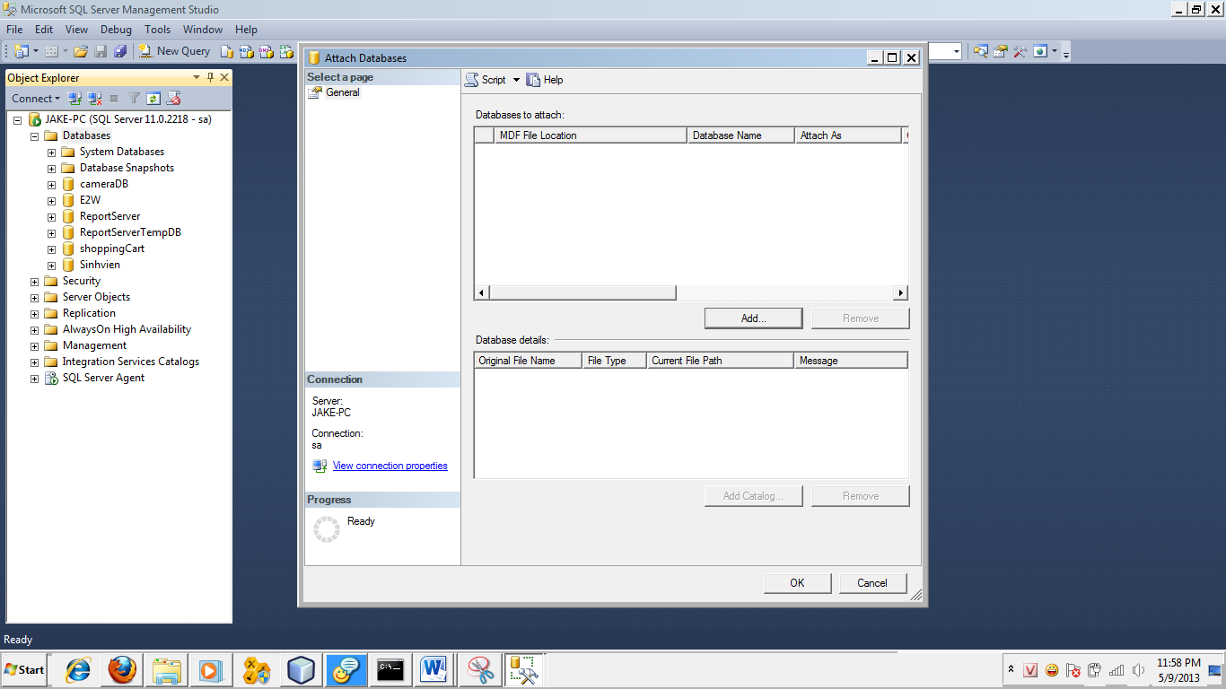

- Choose E2W.MDF
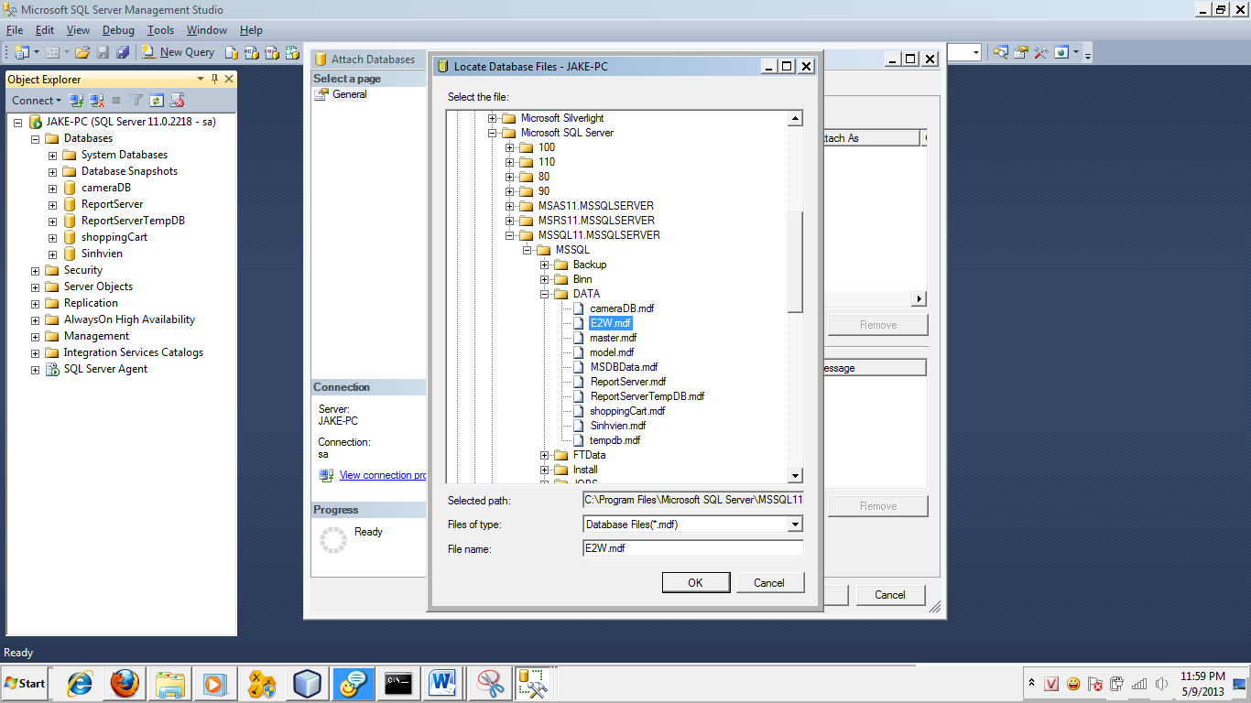
- Click OK
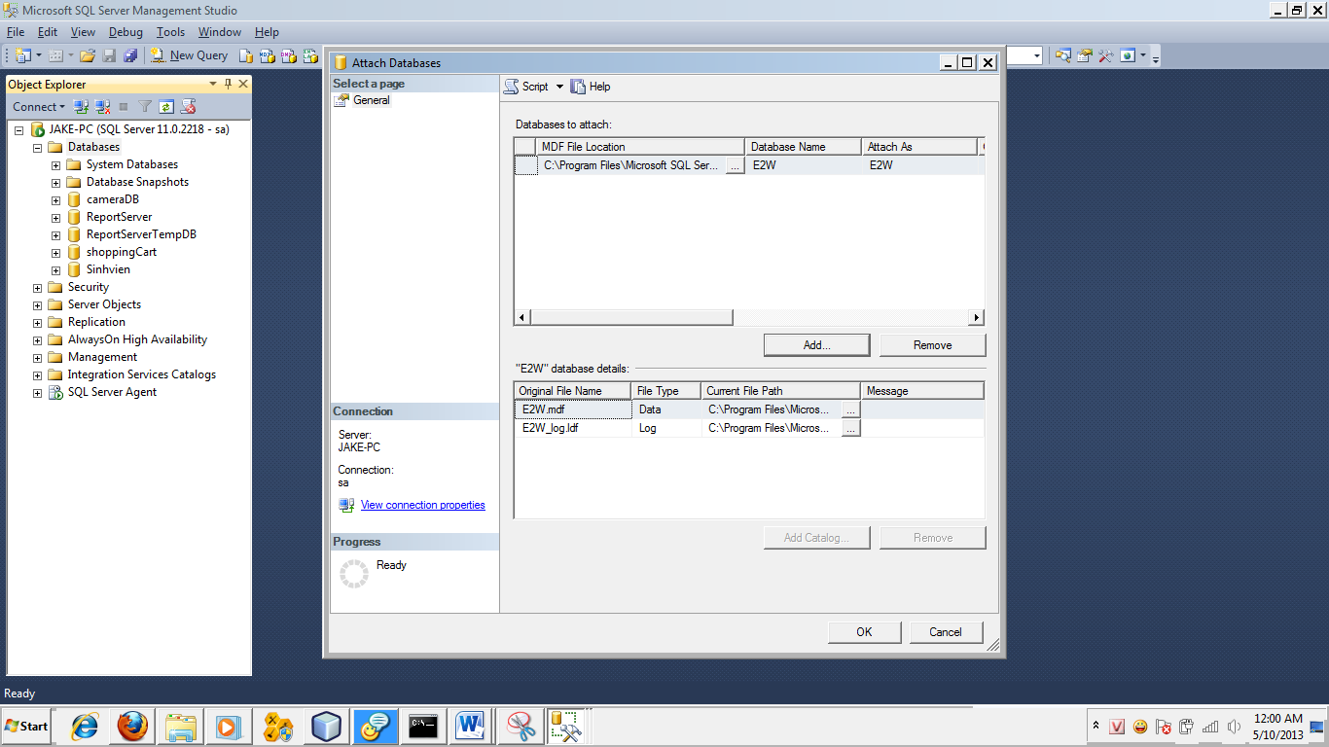
- Click OK
- Finish attach file

There are 2 file e2wDatabaseScriptSQL2005.sql and e2wDatabaseScriptSQL2008 in case the server reject MDF file
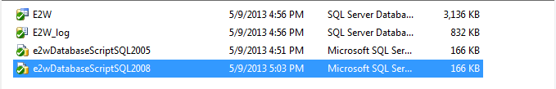
- Open e2wDatabaseScriptSQL2005.sql or e2wDatabaseScriptSQL2008 with SQL SERVER
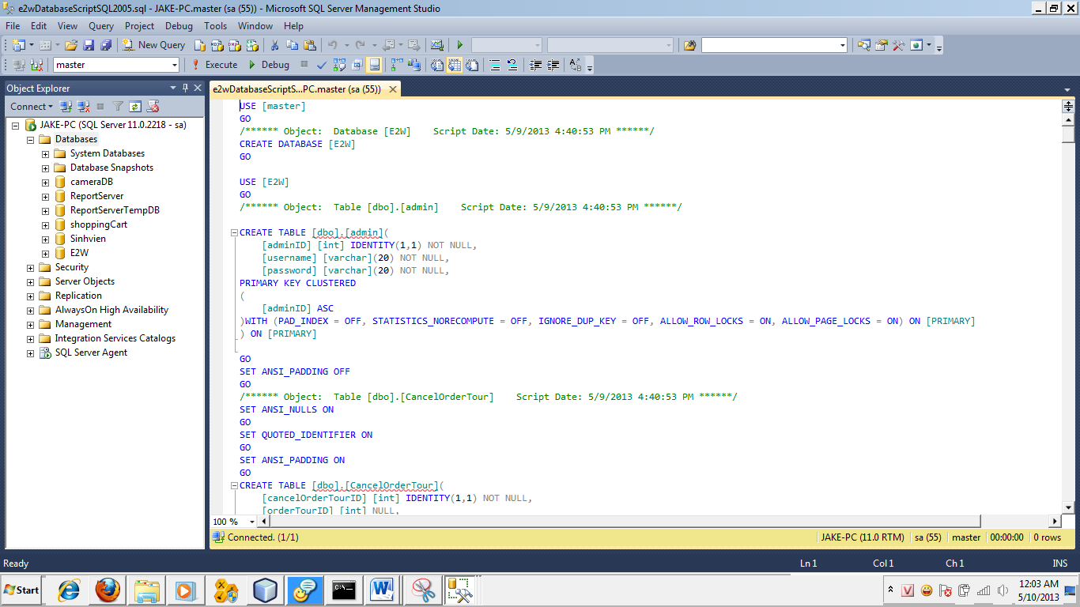
- Ctrl+A → F5 → Finish
Setup website:
Step 1: Copy files from “\eProject_group04_GC0761\ deploy -install \lib\” to “\jboss-5.1.0.GA\server\default\lib”
Step 2: Copy file “jboss-ds.xml” from “\eProject_group04_GC0761\deploy -install\” to “\jboss-5.1.0.GA\server\default\deploy” after edited (edit the username and password of the SQL server )
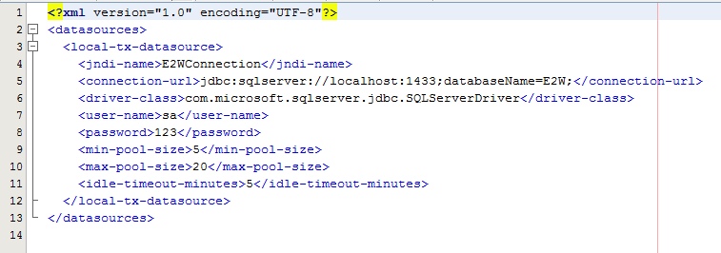
Step 3: Copy file “east2west-ejb.jar” from “\eProject_group04_GC0761\deploy -install\” to “\jboss-5.1.0.GA\server\default\deploy”
Step 4: Copy folder “east2west-war.war” from “\eProject_group04_GC0761\deploy -install\” to “\jboss-5.1.0.GA\server\default\deploy”
IF ERROR OCCUR,COPY FILE “east2west.ear” FROM “\eProject_group04_GC0761\deploy -install\” to “\jboss-5.1.0.GA\server\default\deploy” AFTER HAS DONE STEP 1 AND STEP 2 AFTER EXTRACT FILE “Jboss 5.rar” to run directly from the configured Jboss server

C. Successful Sign
Step 1: Jboss console windows will notify like this
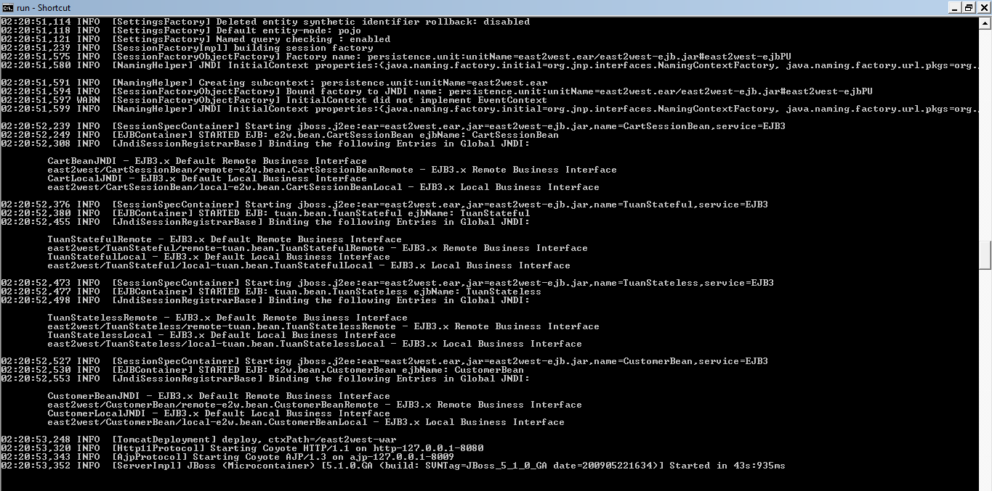
Step 2: open IE/Firefox,open this address : “http://localhost:8080/east2west-war/” and then enter
